

# 

### Semester One Examination, 2020

### Question/Answer booklet

# MATHEMATICS

**QUESTIONS**

**METHODS**

**UNIT 3**

## Section One:

## Calculator-free

|  |  |  |  |  |  |  |  |  |  |  |
| --- | --- | --- | --- | --- | --- | --- | --- | --- | --- | --- |
| WA student number: In figures |  |  |  |  |  |  |  |  |  |  |

In words

Your name

|  |  |
| --- | --- |
| Number of additional answer booklets used (if applicable): |  |

## Time allowed for this section

Reading time before commencing work: five minutes

Working time: fifty minutes

## Materials required/recommended for this section

***To be provided by the supervisor***

This Question/Answer booklet

Formula sheet

***To be provided by the candidate***

Standard items: pens (blue/black preferred), pencils (including coloured), sharpener,  
correction fluid/tape, eraser, ruler, highlighters

Special items: nil

## Important note to candidates

No other items may be taken into the examination room. It is **your** responsibility to ensure that you do not have any unauthorised material. If you have any unauthorised material with you, hand it to the supervisor **before** reading any further.

## Structure of this paper

|  |  |  |  |  |  |
| --- | --- | --- | --- | --- | --- |
| Section | Number of questions available | Number of questions to be answered | Working time (minutes) | Marks available | Percentage of examination |
| Section One: Calculator-free | 8 | 8 | 50 | 52 | 35 |
| Section Two: Calculator-assumed | 13 | 13 | 100 | 98 | 65 |
|  | | |  | **Total** | 100 |

Section One: Calculator-free 35% (52 Marks)

This section has**eight** questions. Answer **all** questions. Write your answers in the spaces provided.

Working time: 50 minutes.

Question 1 (5 marks)

Determine the area bounded by the line $y=-2x$ and the parabola $y=x^{2}-6x$.

Question 2 (5 marks)

A curve, defined for $x>0$, passes through the point $P(2, 3)$ and its gradient is given by

$$\frac{dy}{dx}=6x^{2}-\frac{4}{x^{2}}-23$$

(a) Verify that $P$ is a stationary point, determine the value of the second derivative at $P$ and hence describe the nature of the stationary point. (3 marks)

(b) Determine the equation of the curve. (2 marks)

Question 3 (7 marks)

A bag contains $40$ counters, $15$ marked with $0$ and the remainder marked with $1$. The random variable $X$ is the number on a randomly selected counter from the bag.

(a) Explain why $X$ is a Bernoulli random variable and determine the mean and variance of $X$.

(3 marks)

Each of the $32$ students in a class randomly select a counter from the bag, note the number on the counter and then replace it back in the bag. The random variable $Y$ is the number of students in the class who select a counter marked with $0$.

(b) Define the distribution of $Y$ and determine the mean and variance of $Y$. (3 marks)

(c) Explain why it is important that the students replace their counters for the distribution of $Y$ in part (b) to be valid. (1 mark)

Question 4 (8 marks)

Determine

(a) $f'(x)$ when $f\left(x\right)=\sqrt{4x-3}$. (2 marks)

(b) $\begin{matrix}d \\ \overline{dθ}\end{matrix}\left(θ^{3}e^{4θ}\right)$ when $θ=2$. (3 marks)

(c) $f^{'}\left(\frac{π}{4}\right)$ when $f\left(t\right)=\begin{matrix}1+\cos{t} \\ \overline{ \sin{t} }\end{matrix}$. (3 marks)

Question 5 (7 marks)

Functions $f$ and $g$ are such that

$$f\left(4\right)=2, f^{'}\left(x\right)=18{\left(3x-10\right)}^{-2}$$

$$g\left(-4\right)=2, g^{'}\left(x\right)=18{\left(3x+10\right)}^{-2}$$

(a) Determine $f(6)$. (3 marks)

(b) Use the increments formula to determine an approximation for $g(-3.98)$. (3 marks)

(c) Briefly discuss whether using the information given about $f$ and the increments formula would yield a reasonable approximation for $f(6)$. (1 mark)

Question 6 (5 marks)

The graph of $y=f(x)$ has a stationary point at $(-1, 2)$ and $f^{'}\left(x\right)=ax^{2}+4x+6$, where $a$ is a constant.

Determine the interval over which $f^{'}\left(x\right)>0$ and $f^{''}\left(x\right)<0$.

Question 7 (8 marks)

Initially, particle $P$ is stationary and at the origin. Particle $P$ moves in a straight line so that at time $t$ seconds its acceleration cms-2 is given by $a=8-3\sqrt{t}$ where $t≥0$.

(a) Determine the speed of $P$ after $1$ second. (3 marks)

(b) Determine the speed of $P$ when it returns to the origin. (5 marks)

Question 8 (7 marks)

(a) Determine an expression for $\begin{matrix}d \\ \overline{dt}\end{matrix}\left(6t\cos\left(\begin{matrix}πt \\ \overline{ 6 }\end{matrix}\right)\right)$. (2 marks)

The volume of water in a tank, $v$ litres, is changing at a rate given by $v'(t)=πt\sin\left(\begin{matrix}πt \\ \overline{ 6 }\end{matrix}\right)$, where $t$ is the time in hours. The rate of change is shown in the graph below.

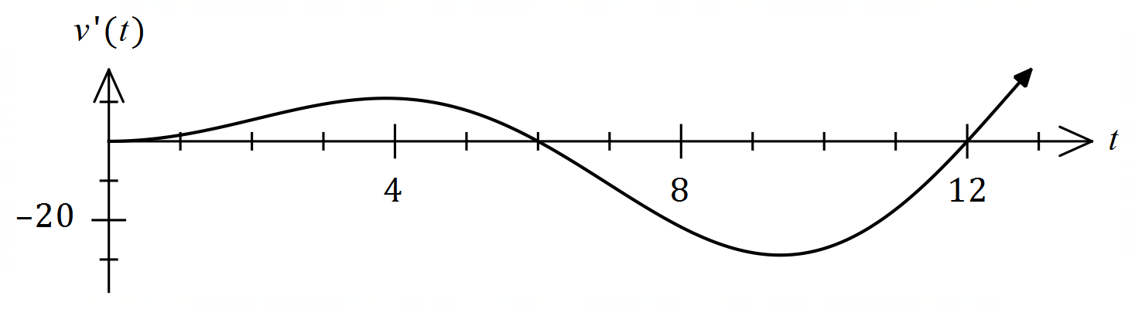

(b) Using the result from part (a) or otherwise, determine the change in volume of water in the tank between $t=0$ and $t=12$ hours. (5 marks)

Supplementary page

Question number: _________